**DATABASE MANAGEMENT SYSTEM**

**LAB 4**

**DML COMMANDS**

NAME: VISHWAS M

SRN: PES2UG20CS390

SEC: F

DATE : 10/09/2022

TASK 1 RESULTS:

1. 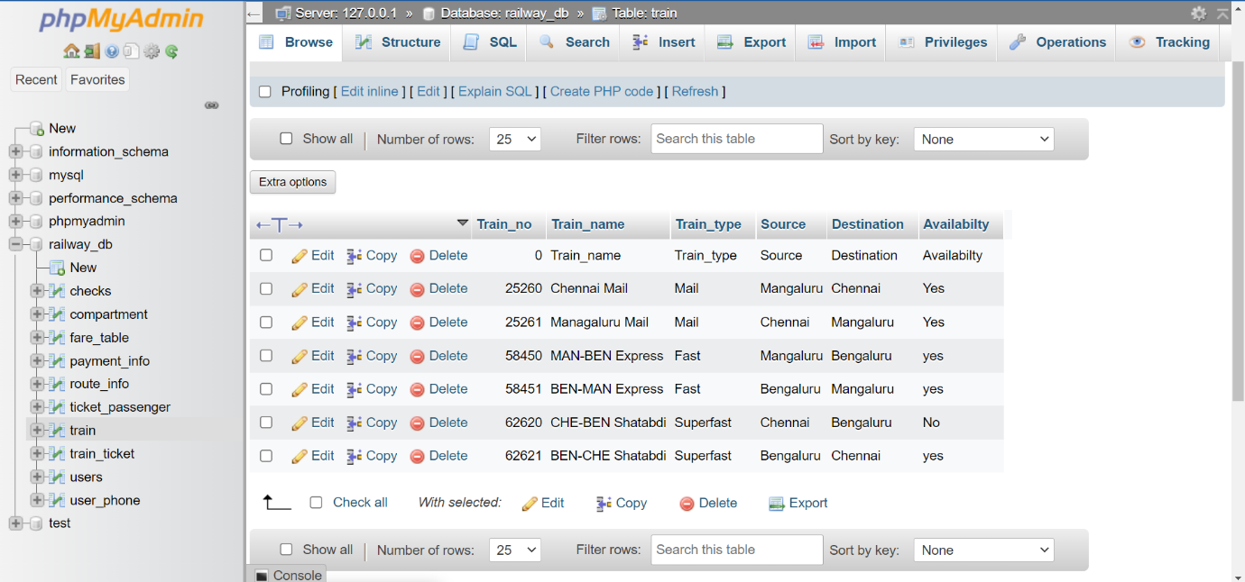
2. 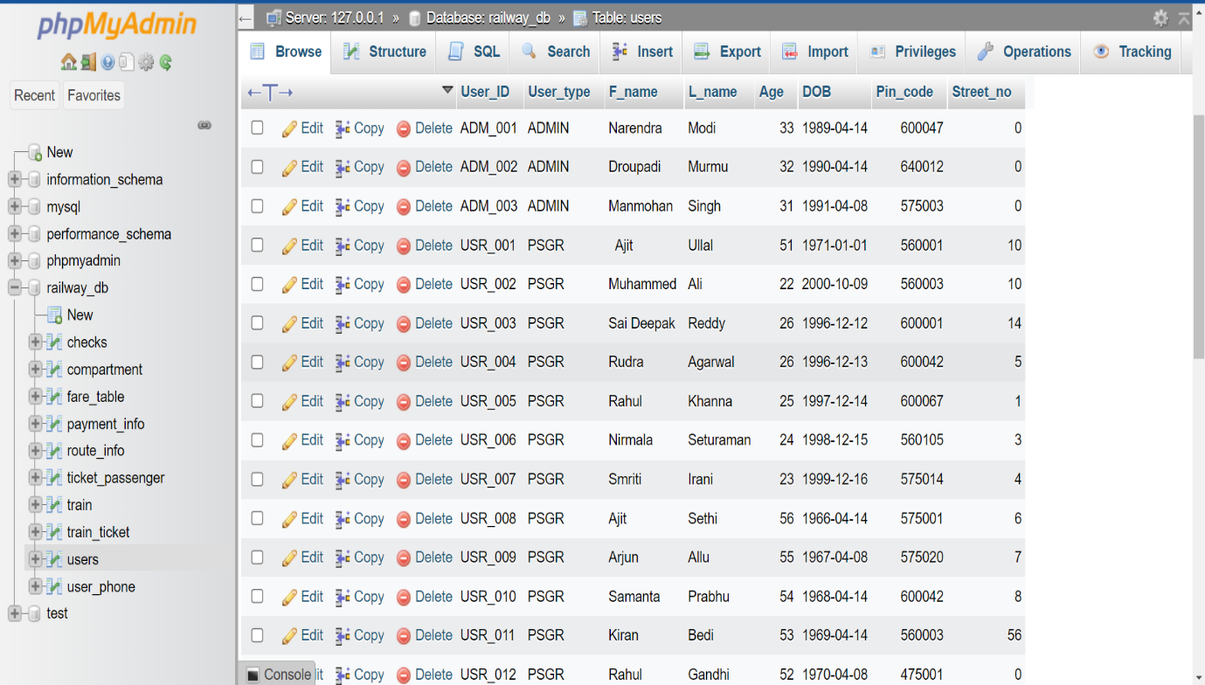
3. 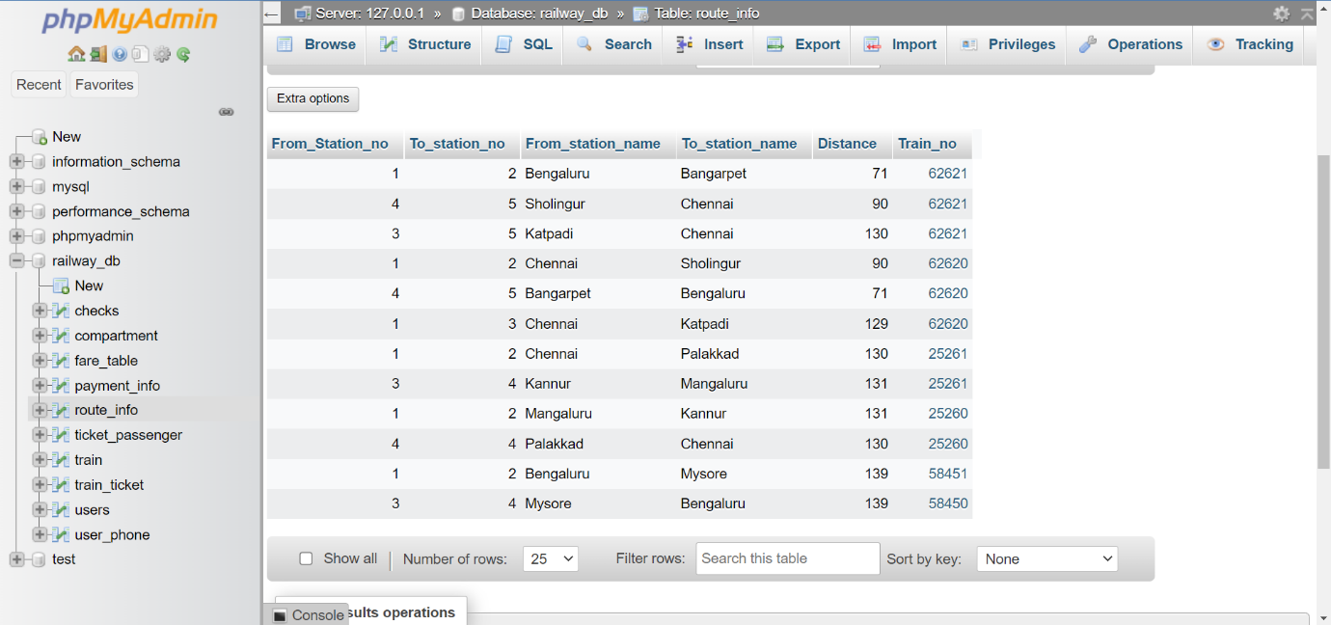
4. 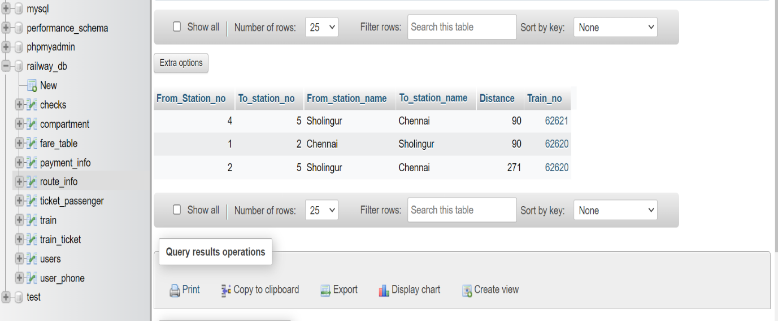
5. 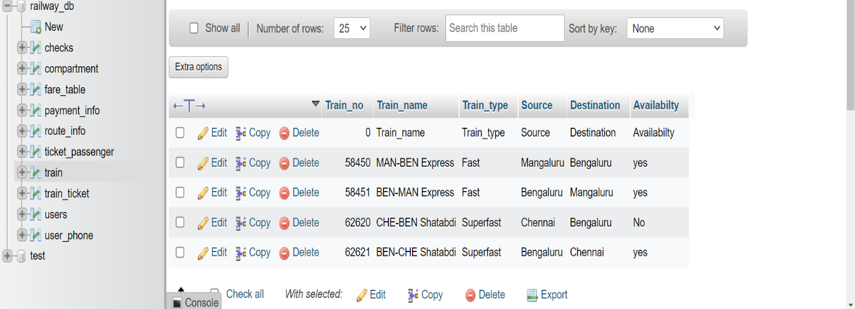
6. 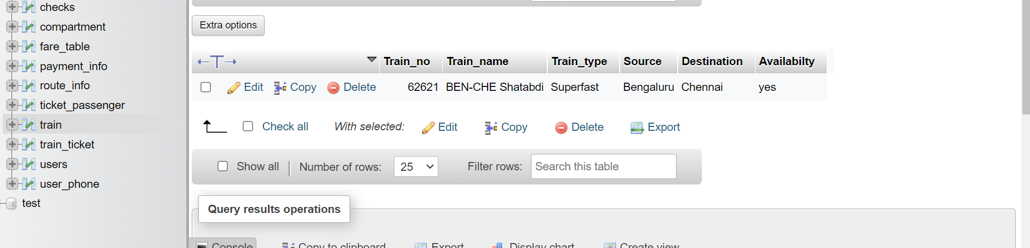
7. 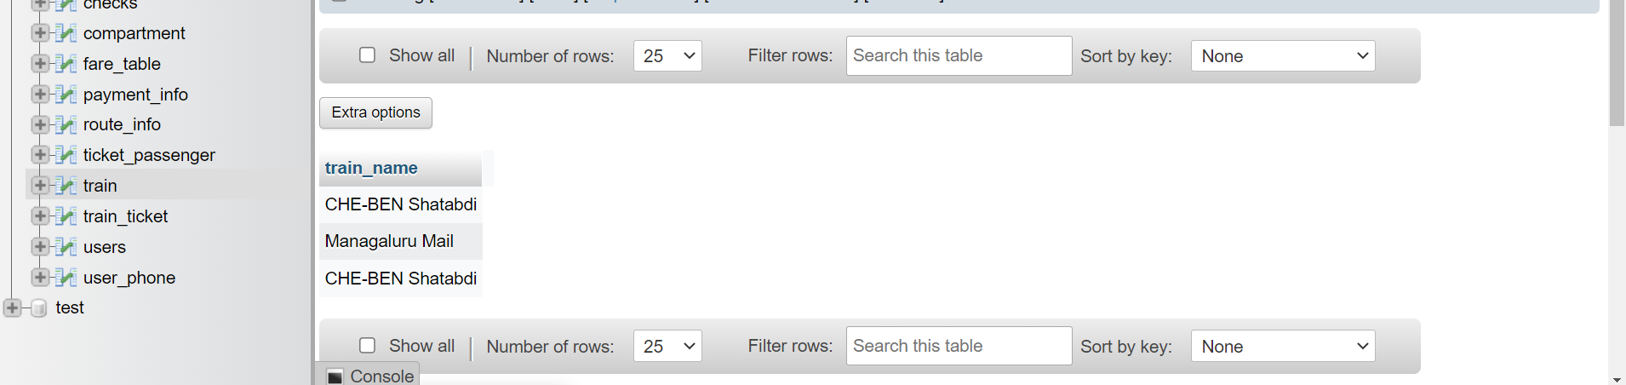
8. 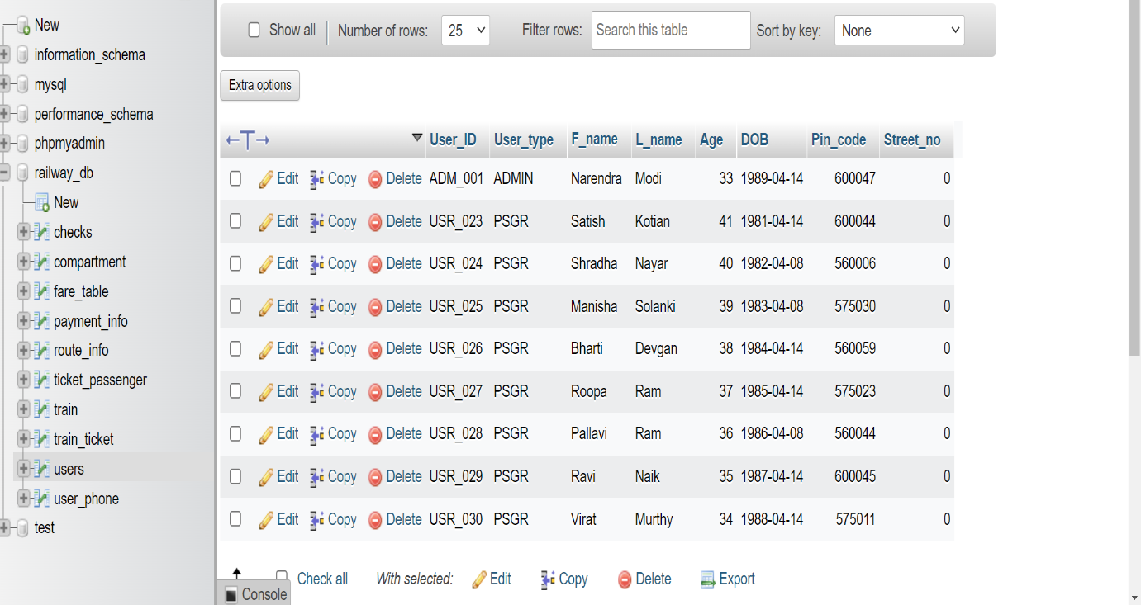
9. 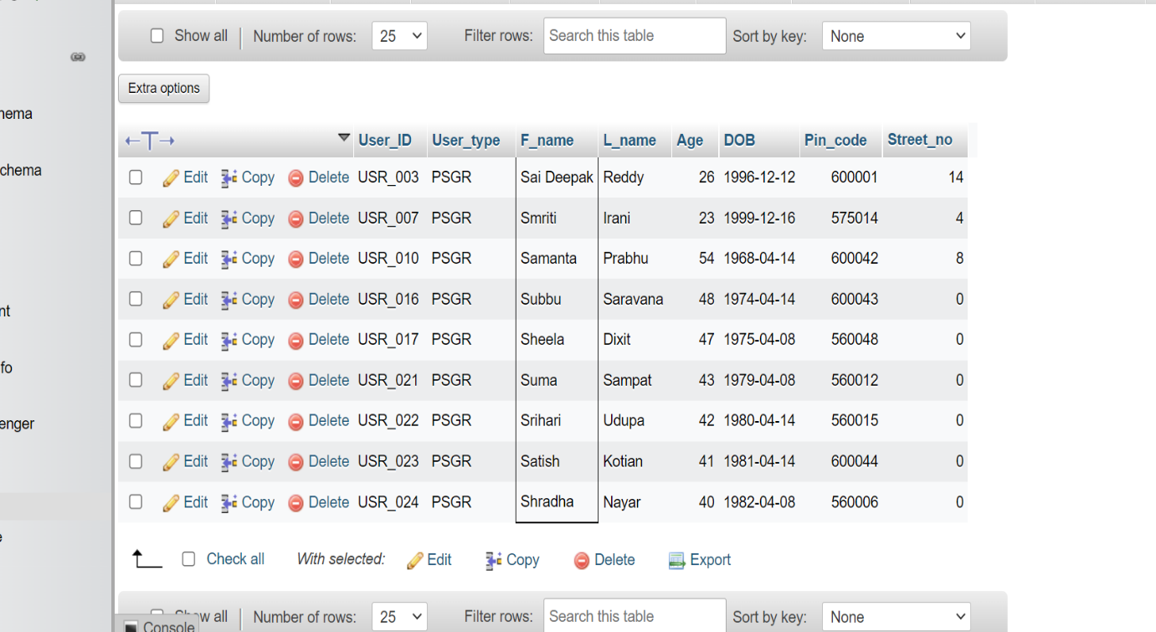

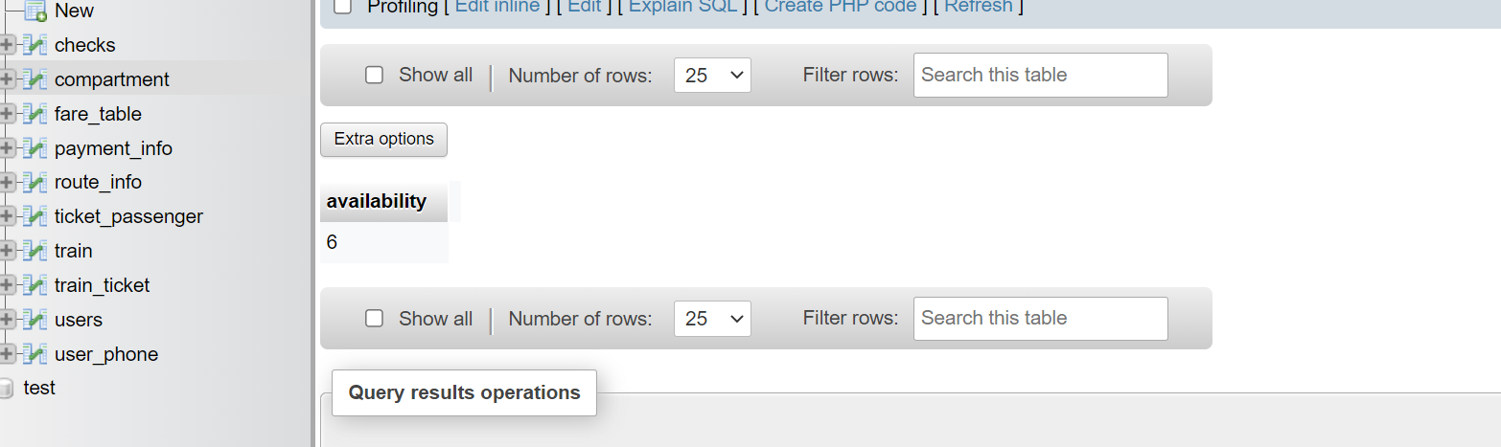

1. 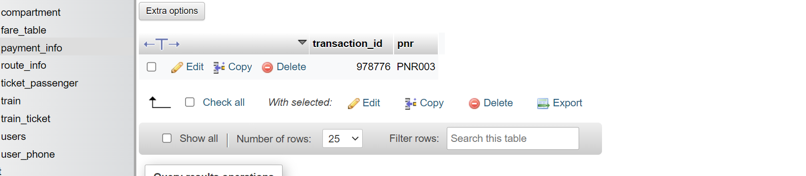

TASK2 RESULTS:

1. 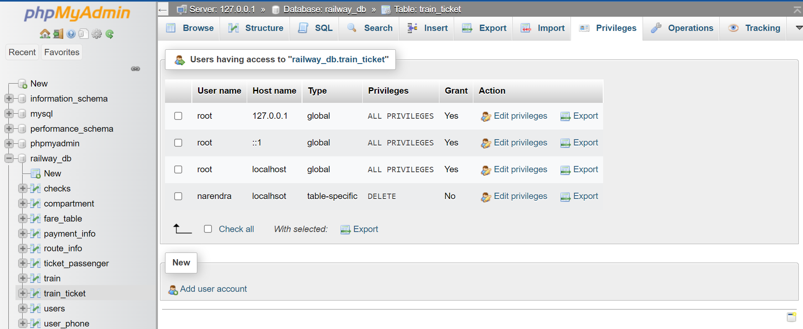i)User named ‘Narendra’ got Delete privileges on table ‘train_ticket’.

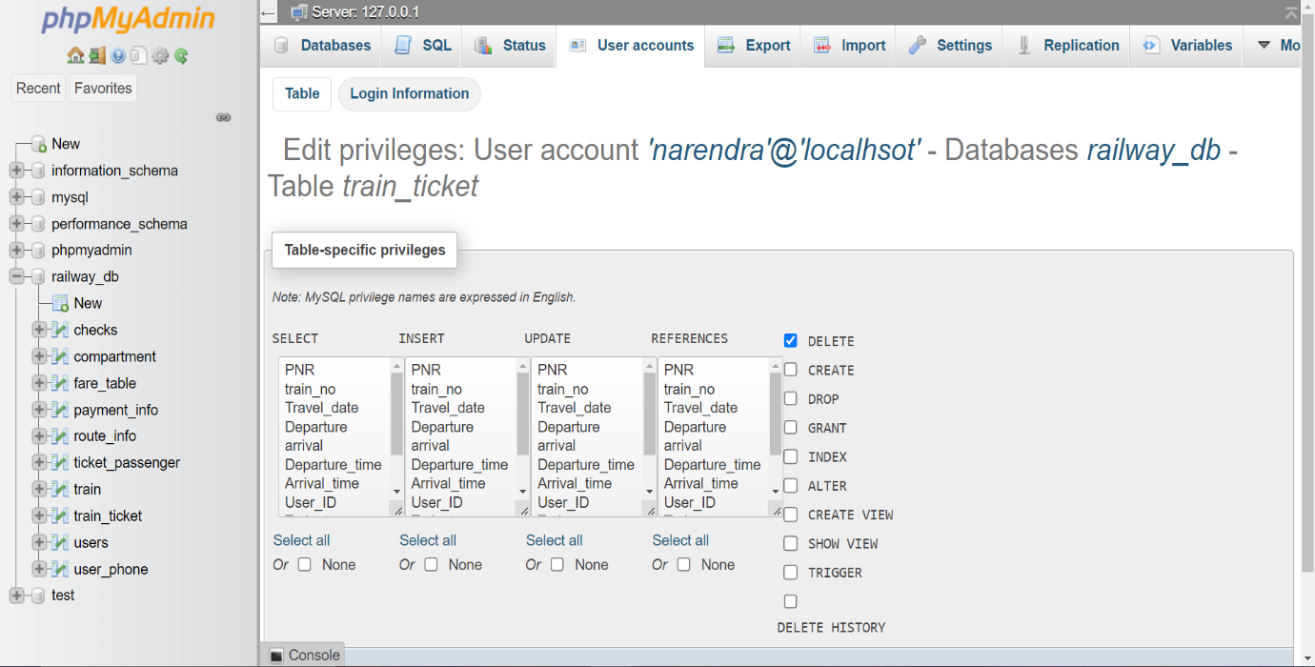

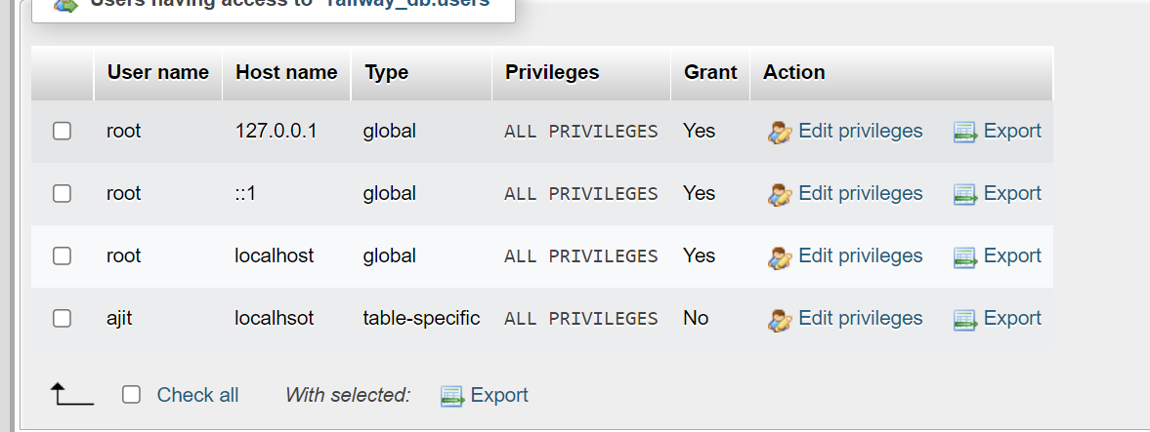ii) User named ‘Ajit’ got ALL privileges on table ‘users’.

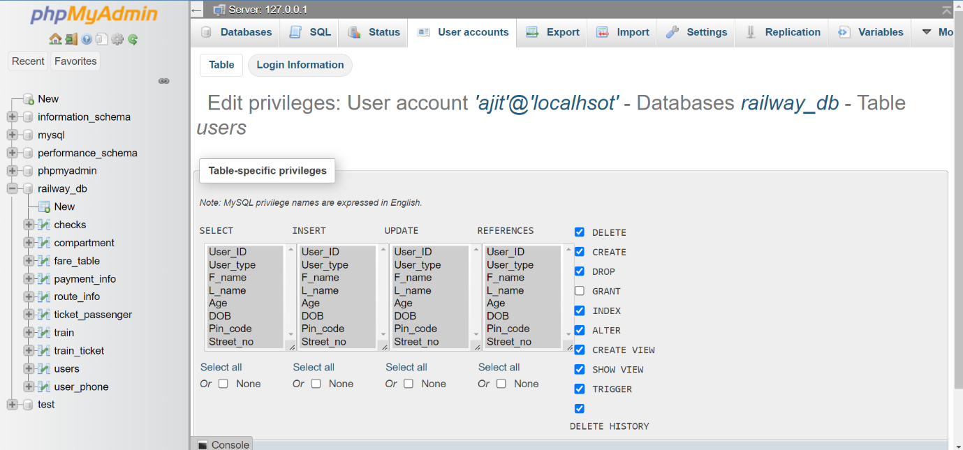

1. 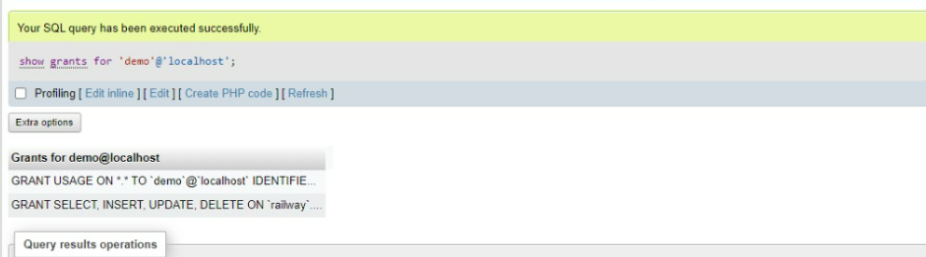Before using REVOKE command:

After using REVOKE command:

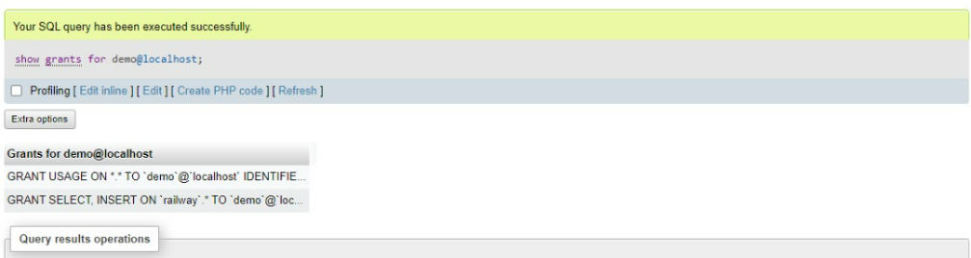

1. 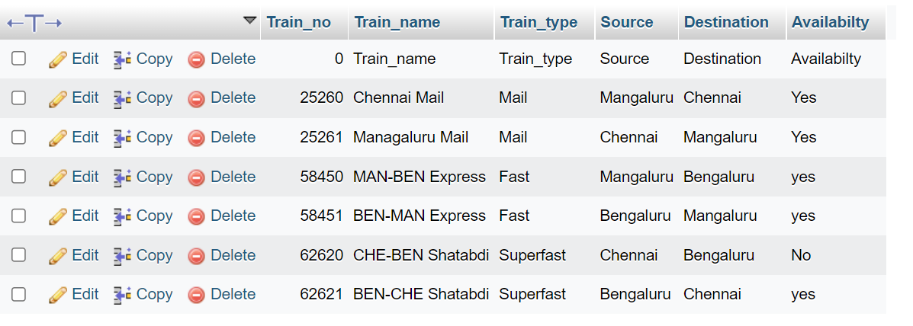Initial table:

After applying savepoints and updating the table:

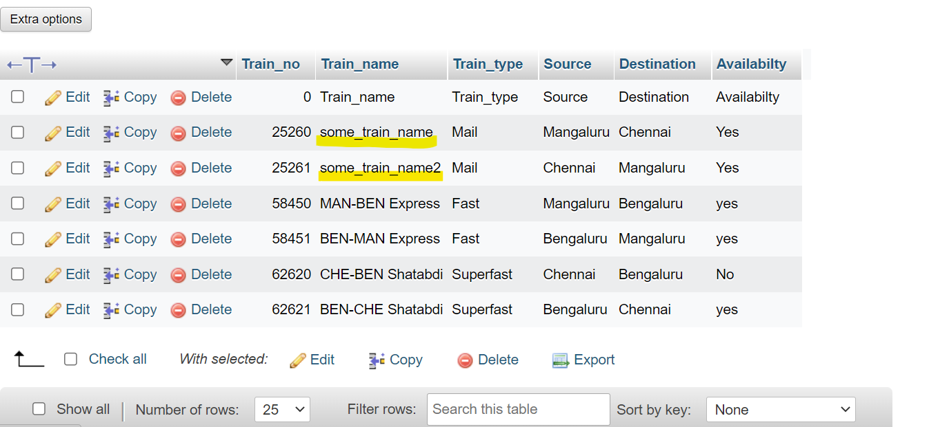

Using rollback went back to savepoint s1:

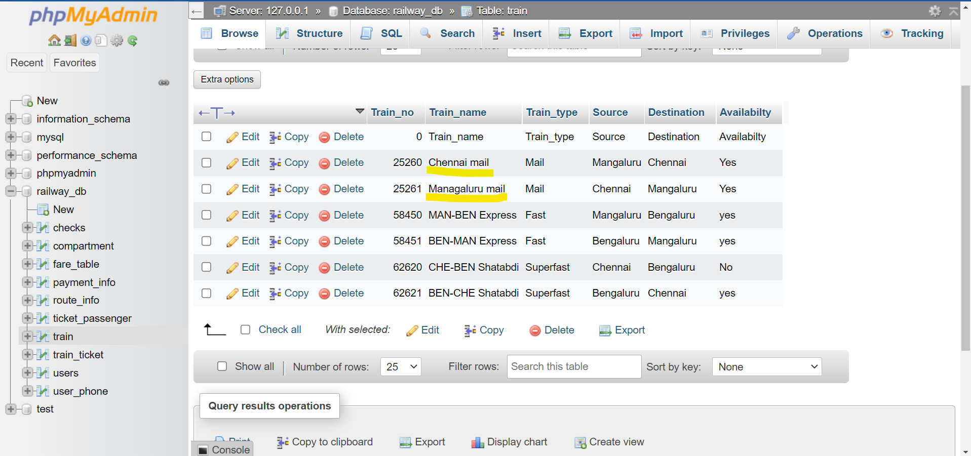

Using commit:

